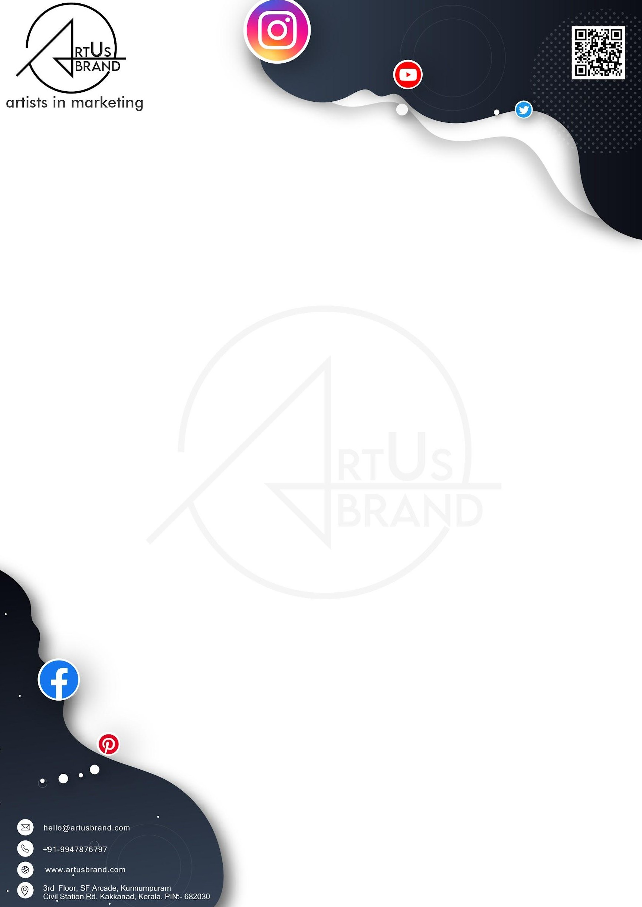

Offer of Employment

Dear Jiji KJ, Date: 17 Jan 2024

We are pleased to offer you the position of Accountant with Artus Brand. We believe your skills and experience will be an invaluable asset to our team. This letter outlines the terms of our offer and your proposed employment with us.

* Position: Accountant
* Start Date:18 Jan 2024
* Working Hours: One day per week. The specific day of the week will be determined based on mutual availability and the needs of our operations.
* Compensation: You will be compensated at a rate of **₹500 per day**.

# Duties and Responsibilities:

* You will be responsible for managing our financial records, including expenditures, payroll, budget reports, and financial forecasting.
* Ensuring compliance with accounting laws and regulations.
* Any other duties reasonably requested by your manager.

# Terms of Employment:

* This position is on an at-will basis, and either party can terminate the employment with appropriate notice.
* You will be required to comply with all company policies and procedures.
* Confidentiality of company information must be maintained at all times.

# Next Steps:

Please confirm your acceptance of this offer by signing and returning a copy of this letter. As a part of the onboarding process, we kindly request that you submit the following documents to our HR department within 5 days from your date of joining:

1. **A copy of your valid government-issued identification card (e.g., passport, driver's license, Aadhaar card, etc.).**
2. **A copy of your degree certificate or the highest educational qualification you possess.**

These documents are necessary for our records and compliance purposes. Please ensure that the copies you provide are clear and legible. You can submit them via email to admin @ artusbrand.com or in person at our office.

We are excited at the prospect of you joining our team and look forward to a productive and successful partnership.

Please feel free to contact us with any questions or clarifications. Sincerely,

**Ajeena Ali CEO**

**Artus Brand**

Accepted by:

Jiji KJ

Signature: